Assignment-5
- Find the sum of numbers from 1 to N
import java.util.Scanner;
public class SumN {
public static void main(String[] args) {
Scanner sc = new Scanner(System.in);
System.out.print("Enter N: ");
int n = sc.nextInt();
int sum = 0;
for (int i = 1; i <= n; i++) {
sum = sum + i;
}
System.out.println("Sum = " + sum);
}
}
OUTPUT
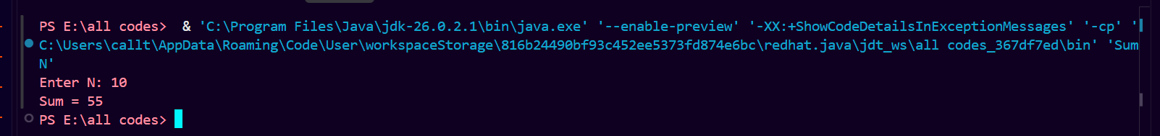

- Print multiples of 5 from 1 to 100
public class SumN {
public static void main(String[] args) {
for (int i = 5; i <= 100; i = i + 5) {
System.out.print(i + " ");
}
}
}
OUTPUT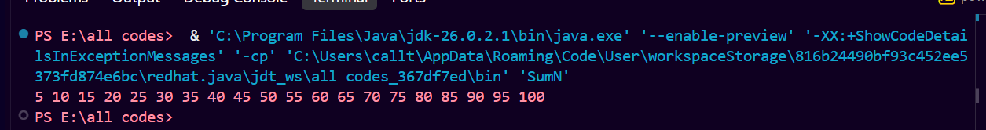

- Count how many numbers are divisible by 3 between 1 and N
import java.util.Scanner;
public class SumN {
public static void main(String[] args) {
Scanner sc = new Scanner(System.in);
System.out.print("Enter N: ");
int n = sc.nextInt();
int count = 0;
for (int i = 1; i <= n; i++) {
if (i % 3 == 0) {
count++;
}
}
System.out.println("Count = " + count);
}
}
OUTPUT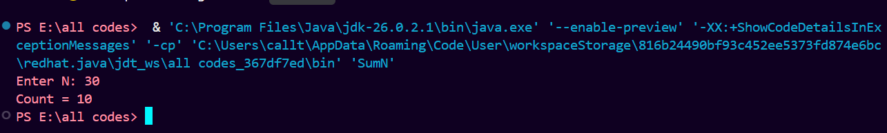

- Check whether a number is prime or Not
import java.util.Scanner;
public class SumN {
public static void main(String[] args) {
Scanner sc = new Scanner(System.in);
System.out.print("Enter a number: ");
int n = sc.nextInt();
boolean prime = true;
if (n <= 1) {
prime = false;
}
for (int i = 2; i < n; i++) {
if (n % i == 0) {
prime = false;
break;
}
}
if (prime) {
System.out.println("Prime Number");
} else {
System.out.println("Not a Prime Number");
}
}
}
OUTPUT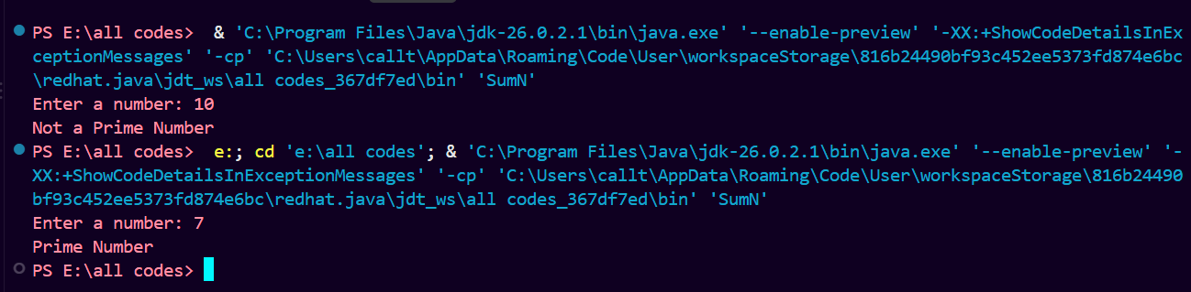
- Reverse of a Given number
import java.util.Scanner;
public class ReverseNumber {
public static void main(String[] args) {
Scanner sc = new Scanner(System.in);
System.out.print("Enter a number: ");
int n = sc.nextInt();
int reverse = 0;
while (n != 0) {
int digit = n % 10;
reverse = reverse * 10 + digit;
n = n / 10;
}
System.out.println("Reverse = " + reverse);
}
}
OUTPUT